**Project on Car Dealership**

Student’s Name

1.SAI TEJA BALUSU -11444840

2.JAI SAI MALAKALAPALLI-11539700

3.MANIDEEP REDDY GADHE-11554879

4.ESHWARA REDDY THIMMAPURAM-11506566

Instructor’s Name

DR.NIROSHA DINAYADURA

Contents

1.0: Introduction 3

1.1: Background Information 3

1.2: Purpose 3

2.0: Requirements 4

2.1: Functional Requirements 4

2.2: Non-functional Requirements 6

2.3: Use Case-Diagram 9

3.0:System Designs 12

3.1: Process Model 13

3.2: Activity Diagrams 15

3.3: Context diagrams 17

3.4: Class Diagram 18

3.5: System architecture diagram 19

4.0: Implementation 22

5.0: Testing 23

6.0: Deployment 24

7.0: Conclusion 24

**8.0: References** 25

**Project on Car Dealership**

# **1.0: Introduction**

The project that has been chosen normally concerns implementation of the system that would in turn enable individuals to perform search for the incoming a new car that the dealers are dealing with. It enables the car dealers to share their challenges that they are facing in the current world (Brousmiche *et al.,* 2018). It details all the involved for the steps in which car dealership can easily be established in the current world.

## **1.1: Background Information**

Car dealership platform would serve an important role in making sure that there is a sharing of information from one dealer to the other. With sharing of challenges and the information regarding new innovation in the current world, the dealers stand an opportunity to move with the current researchers that are been done in the current world (Brousmiche *et al.,* 2018). Therefore, the website would play an important role and would help in updating others on the current changes and challenges that individuals are having in the world.

## **1.2: Purpose**

The purpose of the project is to entirely come up with a website whereby individuals who serves as a car dealer stands an opportunity to easily share ideas. The platform is supposed to make sure that each and every individual all over the world who serves as a car dealer stands an opportunity to easily get better understanding of the challenges that others are facing in the society. At the same time, the solution for different challenges faced by different individuals is the core form of the issues that would be shared and through discussion of the possible solutions, individuals would thus stand an opportunity to easily get their problems been solved (Brousmiche *et al.,* 2018). The website which would be authenticated to all car dealers would thus be very important also at the same time it would educate individuals on the market trends and the kind of the cars that are highly required in the society depending on the preferences and choices of the clients.

# **2.0: Requirements**

As far as requirements are concerned, it has been noted that there are both functional and non-functional requirement for the establishment of the websites. The requirements need to be understood for the car dealers to be aware on how they can link themselves with each other (Brousmiche *et al.,* 2018). In this connection, it is clear that the car dealers would stand an opportunity to easily budget on the implementation and integration of the associated and required operational system. Therefore, the requirements need to be addressed throughout as the proposal proceeds.

## **2.1: Functional Requirements**

Based on the fact that the project that to be implemented is a software engineering project, there is a need to outline all the functional requirements. The functional requirements normally define all sorts of the components that would be interconnected in the system and functions to discharge the designed form of the duties (Brousmiche *et al.,* 2018). They normally offer a description of any given form of the behavior associated with the outputs and inputs of the system. For the project that is at hand, the major forms of the functional requirements that would be needed involves administration functions, authentications, external interfaces, certificate requirements, users and authorization levels for the car dealers. Discussion of the named form of functional requirements are discussed in the section below:

* **User**: The users who are the individuals serving as the car dealers are supposed to make sure that they are able to easily access the platform through creation of their own accounts. After creating their own account, the individuals would be easy to access any form of discussion that is held in the platform. In this perception, they would easily offer their contribution to whatever has been posted in the platform.
* **Administration function**: The administration of the platform should lay down rules and regulations that are governing the platform. They stand high opportunity of regulating whatever an individual is posting in the platform. Following such, there is a content social law that would be applied in the system. They are also at a position of adding, updating menu and deleting any form of the content that is posted in the platform. Following such, there are some car dealers who have been given an obligation of performing such.
* **Authentication details**: The platform is entirely specialized in making car dealers stand an opportunity to easily interact with each other. Following such, each car dealer is required or is assigned a specific form of code that helps in managing their account. For the individuals who are not working as car dealers are not given an opportunity to get an access to the platform as the car dealers are required to submit their administration code for them to stand an opportunity to access the platform which serves as an authentication details.
* **Certificate requirement**: For any individual to authorized in joining the platform, it has been noted that there is a need of slot whereby any car dealer would fit in their certificate satisfying that they are part of car dealers all over the world. The details concerning the information should match with the code given in the certificate. For the individuals who are faking certificates are easily identified as the system would also have a scanner that would be scanning any given certificate code. Following such, individuals who are not authorized to use the platform would be barred completely from accessing the discussion that is held in the platform.
* **External interference**: for the external interference control, the individuals who serves as the managers of the platform are normally required to look for a way in which they can monitor all what is happening in the platform. From the previous studies that have been done, it has been noted that technological advancement has brought about an increased risks of individuals using any form of social media (Mulcahy & Wertz, 2021). Following such, it is recommended that the individuals are throughout supposed to keenly make a close monitor of individuals using the platform and any individual who tends to get in the platform and is not authorized is completely hindered from using the platform.
* **Authorization levels**: For the car dealers who are normally having largest firms are taken as the individuals who have high mandate of controlling the platform. For one to qualify in such, there is a need for everyone to submit the size and details concerning the size of their firms. Following such, individuals are normally ranked in accordance with the size of the firm that a car dealer is operating together with the branches that an individual is having.

With the above form of information, it is clear that all the functional requirements for the firm would have been attained. Besides the above requirements, there is a need of considering non-functional requirements that would be discussed in the section below.

## **2.2: Non-functional Requirements**

In perception of any form of the software, there is an associative form of the behaviors that are linked with the operational systems. The behaviors of the operational systems tend to offer details concerning the non-functional requirements (Nikudinoski, Naumoski & Jovanovska, 2020). In this connection, the non-functional requirements mainly define all what an individual is supposed to do with the system and even the way the proposed software stands an opportunity to fulfil whatever the software is designed to offer to the society. Based on the project that is at hand, the associated non-functional requirements are normally discussed in the section below. They are as follows:

* **Security**: The system or platform is supposed to be integrated in a manner that the only individuals who are having an access to the administration specificity are the only individuals who have been allocated such tasks (Mulcahy & Wertz, 2021). With the other individuals who are at the lower levels of the authorization levels are not given any chance to easily stand an opportunity to delete or add individuals in the platform. The above defines the form of security that is been deployed within the platform.
* **Integrity**: The information within the firm should be associated with integrity whereby the individuals are required to make sure that the user’s passwords are normally saved under the database (Lysenko *et al.,* 2022). The above helps management team to easily control the platform and prevent the users of accounts from been hacked hence the integration of the system enable the privacy within the firm.
* **Maintainability**: The system should be easily used by car dealers all the time that they would like to share a certain form of information regarding challenges that they are facing together with the possible solution not forgetting the current trends in the society regarding cars that are supposed to be sold and are highly need in the market (Mulcahy & Wertz, 2021). Meanwhile, it has been out of the research that the platform is supposed to be highly testable and for modifications it should stand an opportunity to highly allow adjustment of the changes as the technology is changing on daily basis. Following such, it should be designed in a manner that it offers room for such requirements.
* **Satisfaction**: The platform should stand an opportunity to easily make sure that the individuals are continuously making sure that it serves the needs that are desired in the system. At the same time, it is clear that every purpose should be realized during the operation of the platform.
* **Efficiency**: The platform should also allow room for the multiple form of task and should accommodate for several users at the same time. The reason behind such is that car dealers are supposed to be updated on the new changes that are within the market and also should share their challenges in which they expect a forum for discussion to be held. Through the discussion, individuals’ challenges are solved hence enhancing their productivity as well (Mulcahy & Wertz, 2021). In this connection, the platform is supposed to be designed in a manner that everyone in the society who serves as car dealer would end up been satisfied and at the same time would enjoy using the platform.

## **2.3: Use Case-Diagram**

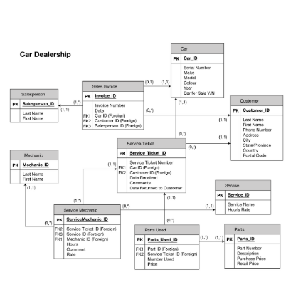

There is also a form of the user’s flow chart that had been witnessed. The flow chart is normally as follows:

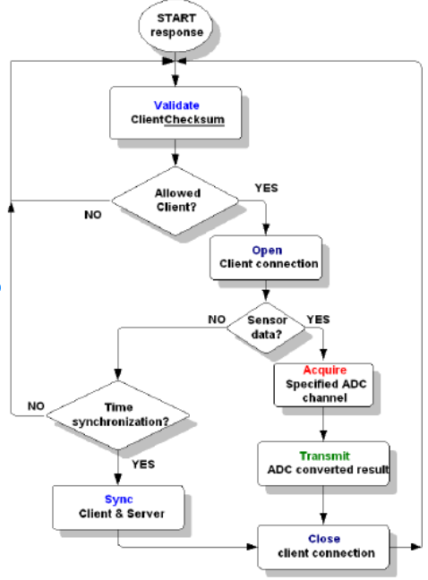

On the other hand, the business model is as follows: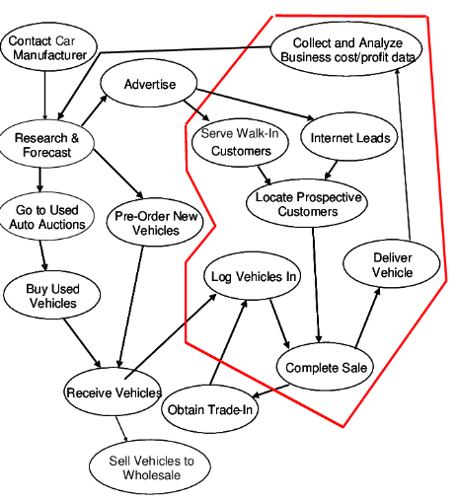

# **3.0: System Designs**

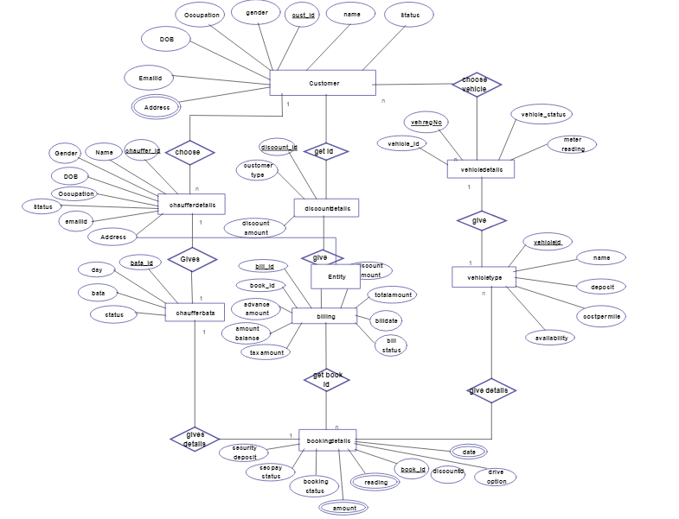

## **3.1: Process Model**

We have followed deft system alongside cascade model. Taking into account the cutoff time of the undertaking, we lacked the capacity to deal with various cycles of the interaction. Thus, we have picked cascade model.

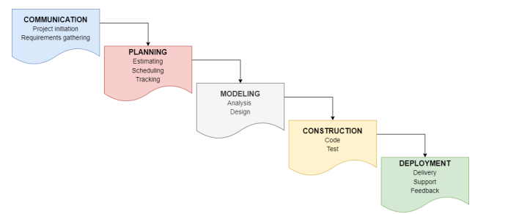

Based on the process design that has been offered in the section above, it has been realized that the individuals are supposed to follow various forms of the stages as they play different forms of roles in the implementation of the process. The roles that are been played in the firm are discussed below:

* **Communication**: The stage is normally the first stage that is supposed to be highly considered. In the project, the stage mainly tends to enlist all forms of the non-functional requirements and functional requirements that are needed in the process. It offers the individuals building up the platform to get better understanding of whatever is required to be incorporated within the platform (Mulcahy & Wertz, 2021). In this connection, the stage is considered as the important form of the stages that are highly recommended.
* **Planning**: The stage also plays an important role in the building up of the platform. The reason behind such is that it offers the builders of the platform to stand an opportunity to make an estimation of the budget and time that is required to come up with the necessary and required details.
* **Modelling**: Through modeling, individuals are required to decide on the appropriate approach that could be used. Based on the researches that have been done previously, it is clear that Agile form of approach would work best for the project simply because with the approach, individuals stand an opportunity to easily get to track the progress of the project and can easily identify the mistakes that individuals could have made during implementation of the project been proposed (Bellini *et al.,* 2017). Therefore, the stage would enable individuals to come up with the Agile that would be applied during the process.
* **Construction**: The stage serves as an important purpose in the creation of the necessary form of framework that would be applied in the system. Through the framework, individuals would end up standing an opportunity to effectively come up with the desired form of the duties as per the expectation of others in the society.
* **Deployment**: The process is very important as it enables individuals to easily understand the challenges that they may come across during the process. Through the challenges that are been faced, the best strategy would be applied in the system implementation (Bellini *et al.,* 2017). With the outstanding form of the challenges, the best strategy that would be applied in the system involved the use of AWS strategy as it would help individuals in coming up with the desired form of the proposed project.

## **3.2: Activity Diagrams**

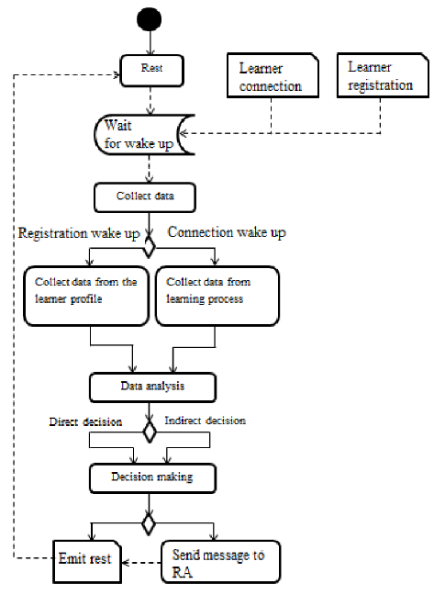

**Admin Activity**

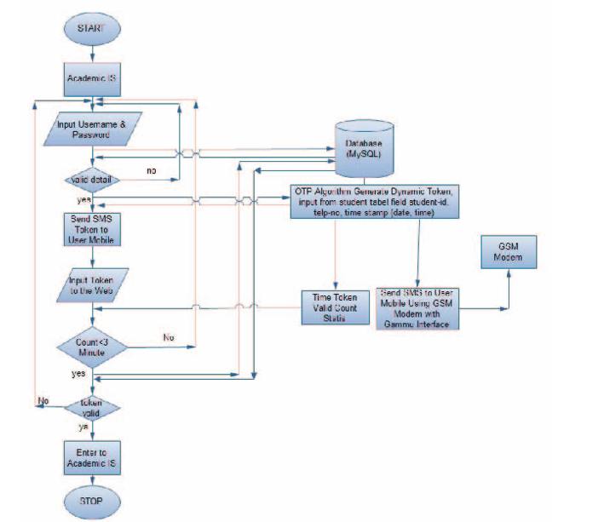

## **3.3: Context diagrams**

The platform mainly helps individuals share their own form of information and experiences that they have attained in the process of work. Based on such, there are certain form of the activities that each of the individual in the society tends to offer to their colleagues for effective exchange of information. The desired forms of the activities that are been shared are as follows:

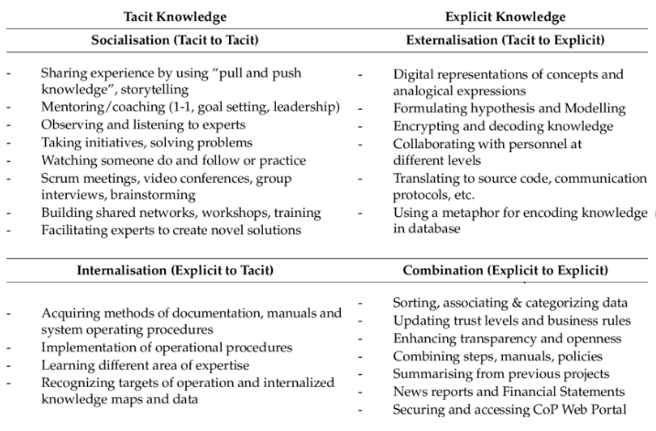

## **3.4: Class Diagram**

Through the class diagram, it is clear that individuals would end up standing an opportunity to easily obtain knowledge from their friends all over the world. The major form of the class diagram that would be applicable is as follows:

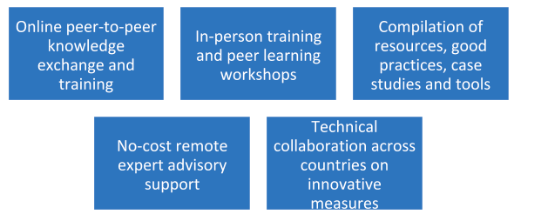

From the diagram that has been offered in the section above, there is an important form of the information that would be attained. The desired form of the information is as follows:

* **Online Peer-to-peer knowledge exchange**: In this case, individuals would end up standing an opportunity to easily exchange their lesson learned from the process of discharging their duties as well as their own experiences (Bellini *et al.,* 2017). Following such, it is noted that the platform would serve an important purpose for the car dealers and hence they would end up expanding their knowledge.
* **In**-**person training**: Through discussion and understanding of each other, several individuals would end up coming together especially the once who are close to one another. In this connection, they would stand an opportunity to easily share their own views.
* **Compilation of resources**: Individuals would be collecting information from the others who are in the same line, learn different ideas from different books and studies as there would be creation of the discussion forum whereby different ideas from different sources and individuals would pop in.
* **Delivery of no cost remote expert advisory report**: Individuals even in remote areas would stand an opportunity to easily get information that is up to date without having travelled to search for the information.
* **Technical collaboration of individuals**: The car dealers would thus stand an opportunity to easily collaborate with each other as current trends are throughout been discussed in the platform.

## **3.5: System architecture diagram**

We have picked MVC design in for this application. The justification behind picking this engineering is the coherent approval in our framework.

* View: View is the UI with the framework. It is additionally called as the show layer. View is created utilizing Angular structure (Bellini *et al.,* 2017). All the UI is planned utilizing Angular. This layer is answerable for setting up the information and introducing it to the client in the ideal organization.
* Regulator: We have involved Spring boot structure for the backend execution. It has two layers in it. Business layer in is where all the client demands are being approved and business rationales are constructed. At the point when a solicitation is being sent from the Presentation layer, the solicitation is approved in light of the rationale created in Business layer and the reaction is being shipped off the client in JSON design.
* Model: We have the information access layer additionally in the spring boot from where we can get to the data set. The information is gotten to from SQL data set and afterward shipped off the frontend.

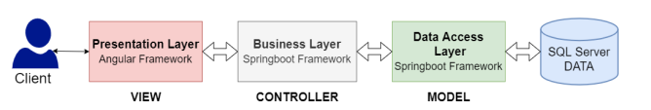

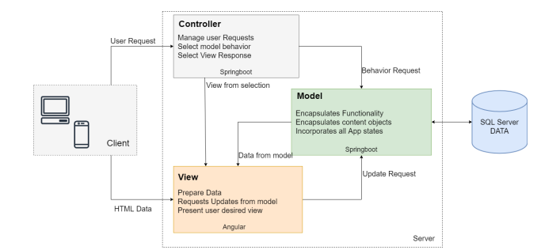

# **4.0: Implementation**

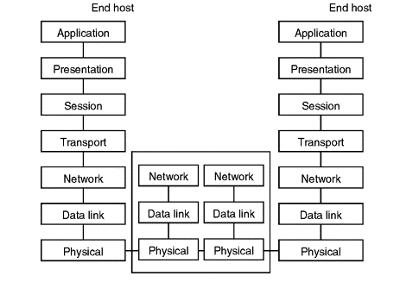

# **5.0: Testing**

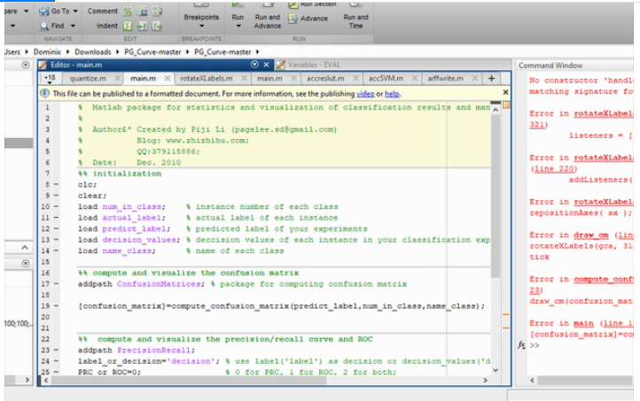

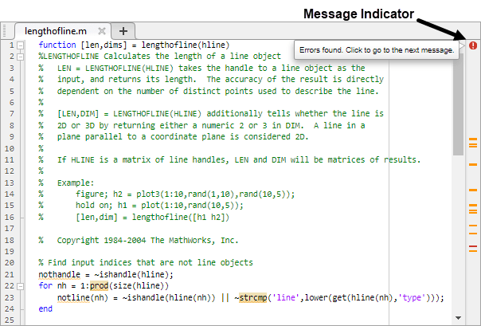

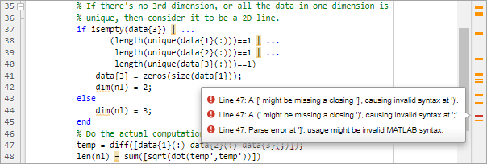

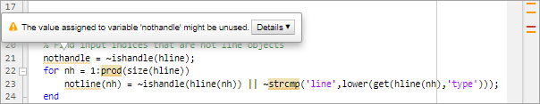



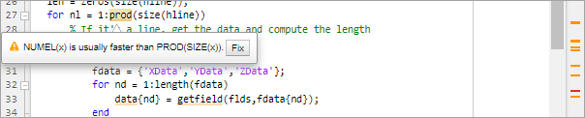

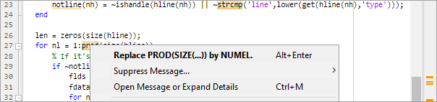

open(fullfile(matlabroot,'help','techdoc',...

'matlab_env', 'examples','lengthofline2.m')

**What it is:**

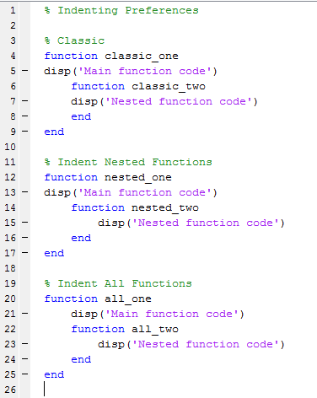

**What the system would look like:**

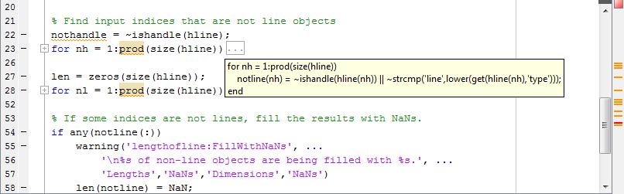

# **6.0: Deployment**

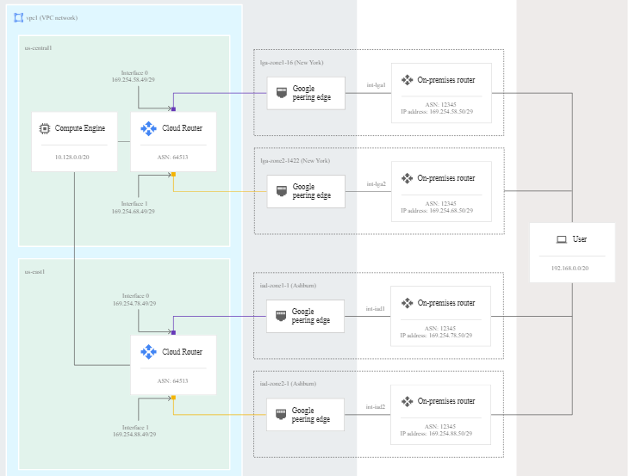

# **7.0: Conclusion**

In conclusion, it has been noted that the process that has been proposed would serve an important purpose in the entire would. The reason behind such is that individuals who serve as car dealers all over the world would stand an opportunity to easily exchange their views and ideas based on whatever they have gained out of their own experiences. At the same time, it is realized that such individuals would stand an opportunity to easily solve their associated challenges. Thus, the proposed form of the project is very useful in various dimensions.

GIT HUB LINK :

https://github.com/saitejabalusu3/SE_PROJECT

# **8.0: References**

Bellini, E., Dell'Era, C., Frattini, F., & Verganti, R. (2017). Design‐driven innovation in retailing: An empirical examination of new services in car dealership. *Creativity and Innovation Management*, *26*(1), 91-107.

Brousmiche, K. L., Heno, T., Poulain, C., Dalmieres, A., & Hamida, E. B. (2018, February). Digitizing, securing and sharing vehicles life-cycle over a consortium blockchain: Lessons learned. In *2018 9th IFIP international conference on new technologies, mobility and security (NTMS)* (pp. 1-5). IEEE.

Lysenko, Y. V., Lysenko, M. V., Kamdina, L. V., Simchenko, O. L., & Chazov, E. L. (2022). Digital Architecture of Project Management—Improving the Performance. In *Proceeding of the International Science and Technology Conference" FarEastСon 2021"* (pp. 753- 766). Springer, Singapore.

Mulcahy, C. A., & Wertz, J. A. (2021). Using Project-Based Learning to Build College and Career Readiness Among Diverse Learners. *TEACHING Exceptional Children*, *53*(5), 341-349.

Nikudinoski, S., Naumoski, A., & Jovanovska, E. M. (2020). Mapping of Automobile Dealership Outlets in Skopje.